# INTRODUCTION

New York City is the most crowded city and the financial capital of the US. The city hosts many people from different cultures while also providing plenty of room for launching a business. For some decades, business owners and entrepreneurs are interested in starting a business in the city of New York. The city is known to be a hub for banking, finance, marketing, tourism, culture and real estate as a result, very attractive for service sector as well. The city is known to be famous for its international cuisine as many people from many different cultural backgrounds have been migrating to New York for decades.

# BUSINESS PROBLEM

Our client wants to open a Sushi bars in Manhattan area. However, the market is very competitive because there are already many Sushi barss in **Manhattan** borough and strategic planning is of great importance. As the analysts in a famous consultancy company, we are asked to **determine the most suitable neighborhood to open a Sushi bars**.

**Target audience:**

Investors who want to open a new restaurant in New York can benefit from this project by changing the restaurant type.

# DATA

To find the best location for our Sushi bars, our consultants will use the following sources:

* The city of Newyork is composed of of 5 boroughs and 306 neighborhoods in total. In order to succesfully segment the neighborhoods to explore them, we need:
  + a dataset that contains the 5 boroughs and the neighborhoods that exist in each borough
  + the latitude and logitude coordinates of each neighborhood
* The dataset can be found on this link: <https://geo.nyu.edu/catalog/nyu_2451_34572>
* Newyork city geographical coordinates data will be used as input for the Foursquare API Newyork city geographical coordinates data will be utilized as input for the Foursquare API to obtain the venues information. Moreover, Sushi category Id 4bf58dd8d48988d1d2941735 is used for retrieving data from Foursquare API.

<https://developer.foursquare.com/docs/resources/categories>

Sushi category Id - 4bf58dd8d48988d1d2941735

# METHODOLOGY

The methodology from Lab in Week 3 is the basis for this project. First, addresses were converted into their equivalent latitude and longitude values. Then, to visualize them, they were superimposed on a map using Folium library. Below is the result of the first conversion:

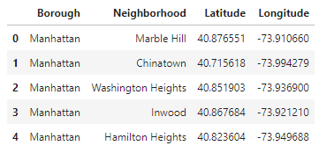

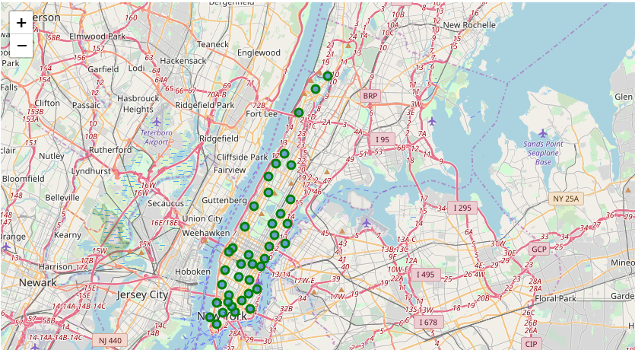

Then, to explore the neighborhoods in Manhattan, the Foursquare API was utilized. They were retrieved from Foursquare and again superimposed on the NY map.

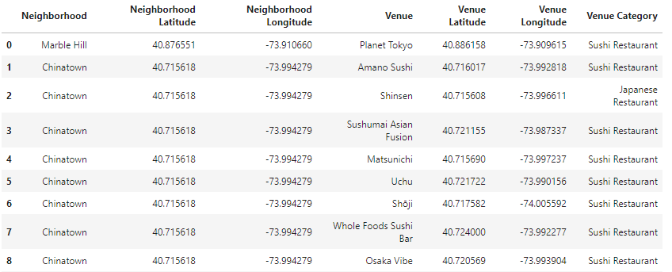

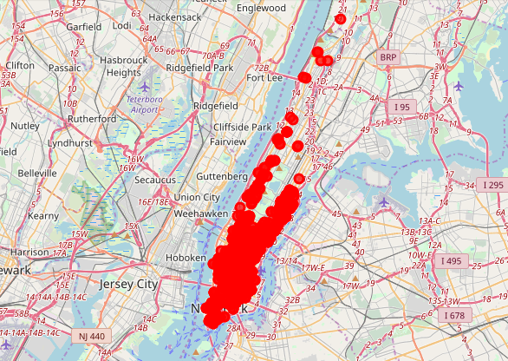

## CLUSTERING

Using the Sckitlearn library, K-means algorithm was used to group the neighborhoods. The number of clusters was selected to be 5. Folium library was used to visualize the neighborhoods in Manhattan and its clusters.

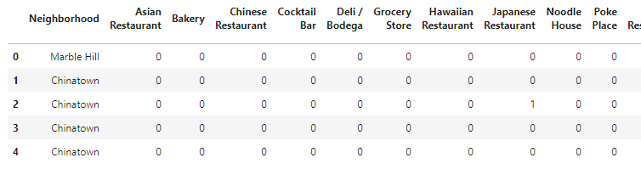

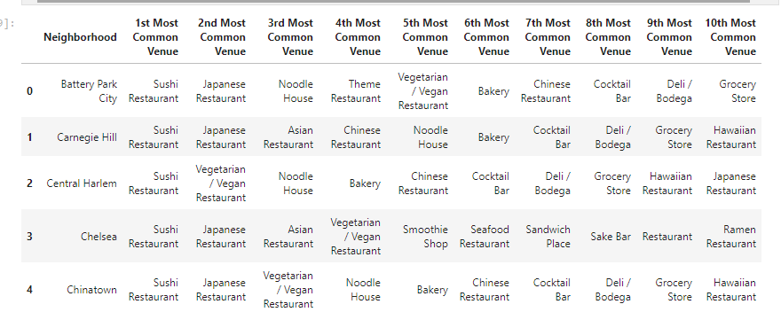

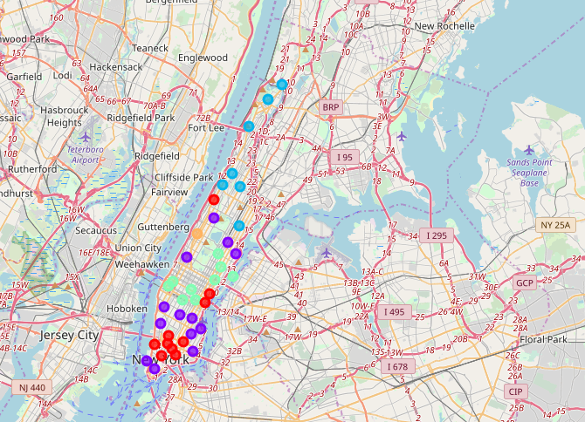

# RESULTS

The clusters were determined as the following:

**Cluster 0:**

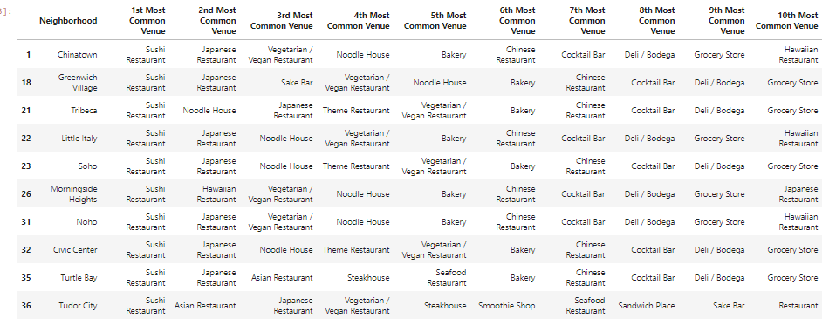

**Cluster 1:**

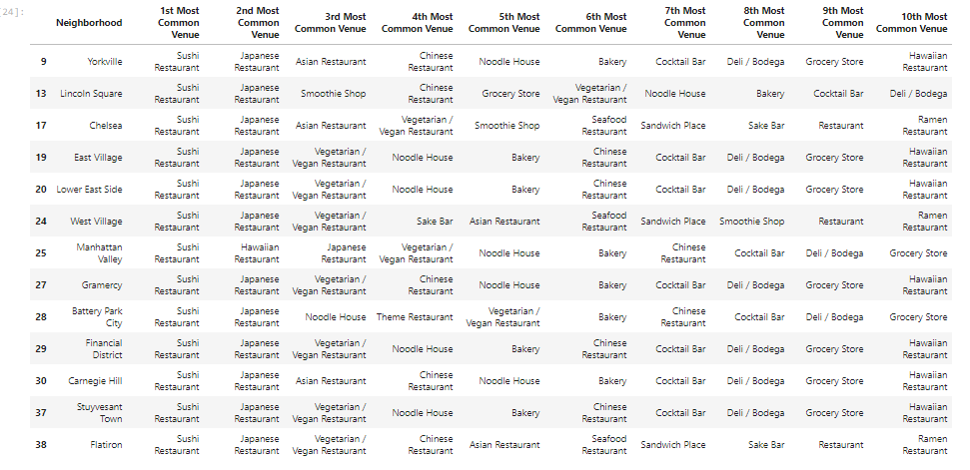

**Cluster 2:**

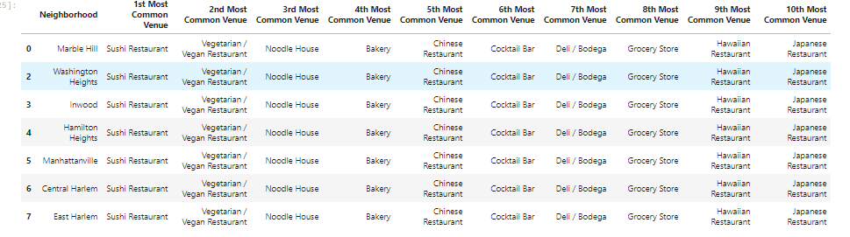

**Cluster 3**

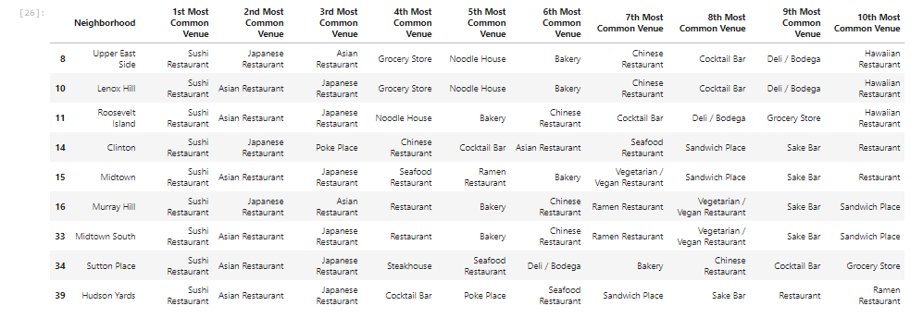

**Cluster 4**





**Upper West Side (Cluster 4) area is the best places to open a new sushi bar. We recommend our client to open a new sushi restaurant as it is the most common venue in all the clusters.**

# **DISCUSSION**

This section focuses on the observations made by our consultants.

The analysis made on limited amount of data and this might affect the generalization based on the proposed method. There is room for improvement by including more data to improve the accuracy of the results.

* On the downside of New Your there is fierce competition, so it is very risky to start a business in this area.
* detailed analysis can be made by taking other factors into account such as ease of transportation, opening hours of restaurants, the surroundings an so on.
* There is also potential for opening a Japanese restaurant on the upper side as there are not hardly any restaurants of this type.

# CONCLUSION

There is still room for further improvement as noted earlier. This analysis and methodology can be used to identify not only to decide which area is suitable to open a sushi bar but also for other venues such as bars, gym, theater hall and so on. However, the goals of the project were met.